


Project Navodaya

ABAP Technical Specification

Document Information

Document Number
Title | RAP Application for ZGGL_FPD2
Document Purpose | Optimization of report ZGGL_FPD2
Key Words
Document Status | Final
Contact for Enquiries | Arnav

Document Change Control :
Release | Description | Created by | Date | Reviewed by | Date | Approved by | Date
01 | RAP Application for ZGGL_FPD2 | Arnav | 22-05-2025

Header
Area (R/3Module): | ISU |  |  |  |  | Date: |  | 22-05-2025
Requested by: | GAIL ISU team
Title: | RAP Application for ZGGL_FPD2
Short description: | Optimization of report ZGGL_FPD2
Functional Developer: | Harshvardhan Rathore (SAP) |  |  |  |  |  | Phone: | +91
Technical Developer: | Arnav Johri |  |  |  |  |  | Phone: | +91 9971324400
Program name:
Type: | Change Request Development Request(Creation) Rework
Program type: (select the check box) | Conversion Batch Interface Online Interface Report  Form Enhancement Extension Dialog  Modification Unknown Others BAPI  ALE/ IDOC Application Development
Priority: | Very High High Medium Low
Complexity: | Very High High Medium Low
Specify known SAP functionality: |  | <Specify the related SAP transactions>
Cross Reference Documentation:
Only for Interfaces:  Type of interface:  Direction of interface:  Frequency: |  |  |  | Real-Time Batch  Inbound Outbound Both  Daily Weekly Monthly  Biweekly Other:
Only for Reports:  1. The report will be created via:  2. Requested characteristics: |  |  | Standard Report  Report Painter Report Writer ABAP Query  ABAP Program Info System  Drill-down Pushbuttons Sort  Entry files Others: _____________________
Generic question:  1. Impact of not creating the program: |  |  | legal requirements will not be fulfilled  lack of information required for the business  lose functionality compared to the old system  others: could have duplicate data entered into the system_
Development labor estimate:
Are there any alternatives in the standard system: |  |  |  |  | Yes No
Describe the alternative found:
Reason why this alternative was not acceptable: |  |  |  |  | Performance problems Complexity  Others: The transaction to initiate

Technical Specification
3.1. Technical Report Created:

Root CDS: yGGL_FPD2_Sec_Dep_Rpt
Entity Set: YCE_ZGGL_FPD2_SEC_DEP_RPT
Service Defination : YSD_ZGGL_FPD2_SEC_DEP_RPT
Service Binding : YSB_ZGGL_FPD2_SEC_DEP_RPT

Development Overview

Sr. No | Program Name | Transaction Code | Transport Request No | Dependency/ TR Sequence
1 | ZGGLR_ISU_SD_FPD2 | ZGGL_FPD2 | SBRK902960

Development Details

Code
Screen:

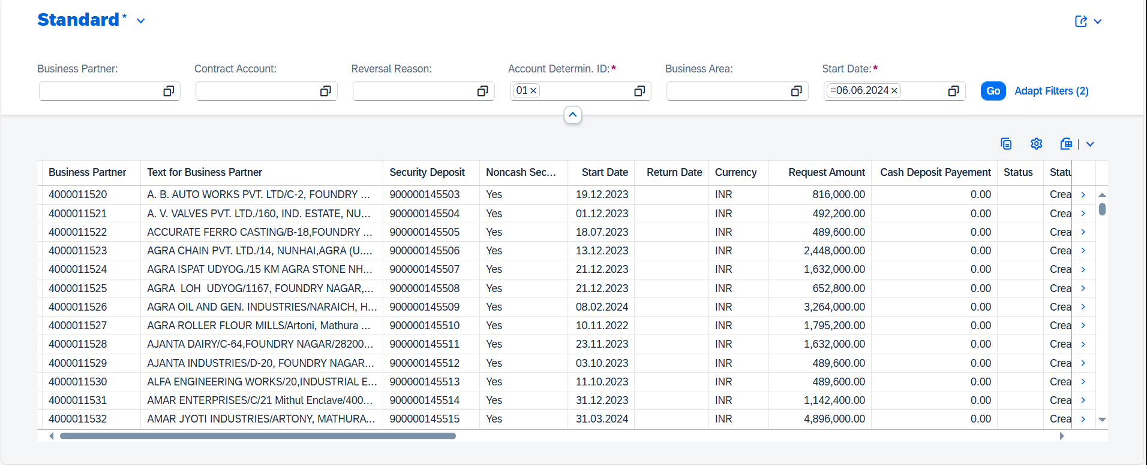

Logic:

1. CDS: yGGL_FPD2_Sec_Dep_Rpt
This CDS view fetches data from table fkk_sec referred to as “a” with total 7 left outer joins and groups them by security deposit (security) and currency key (waers) for max/min.
1.1 Data is fetched from fkkvkp referred to as “b” based on a left outer join where there are matching contract account number and security deposit reserved from a is empty or reversal reason is empty, also standard company code in “b” is equal to ‘9000’.

1.2 Data is fetched from fkk_sec_c referred to as “c” based on a left outer join where there is matching security deposit with “a”.

1.3 Data is fetched from fkk_sec_n referred to as “d” based on a left outer join where there is matching security deposit with “a”.

1.4 Data is fetched from fkk_sec_req referred to as “e” based on a left outer join where there is matching security deposit with “a”.

1.5 Data is fetched from dfkkop referred to as “f” based on a left outer join where there is matching business partner number (gpart) with “b” table and matching contract account number (vkont) with “a” table and main transaction for line item (hvorg) = “0020” and sub-transaction for document item (tvorg) is either “0020” or “0010”.

1.6 Data is fetched from but000 referred to as “g” based on a left outer join where there is matching business partner number with “b”.

1.7 Data is fetched from adrc referred to as “h” based on a left outer join where there is matching name 1 of organisation with “g”.

1.8 The final CDS view comprises of the following fields:
- a.security
- b.gpart
- b.vkont
- c.vtref
- e.nrzas
- a.non_cash
- d.typ
- a.reason
- a.rev_reason
- d.gpart_guarantor
- a.sec_start
- a.sec_return
- a.waers
- c.request
- d.nc_status
- d.refno
- a.ikey
- d.sec_expire
- a.opbel
- b.kofiz_sd
- b.gsber
- f.hkont
- g.name_org1
- h.street
- h. post_code1
- h. city1
2. Custom Entity: YCE_ZGGL_FPD2_SEC_DEP_RPT
Once the data is fetched from the custom class , a custom entity is created to define the UI of
the Fiori app.
3. Service Definition Exposure: YSD_ZGGL_FPD2_SEC_DEP_RPT
Once the metadata is defined for the CDS view entity elements, it is exposed through a service definition. This step makes the data accessible for external systems to consume.
4. Service Binding and Maintenance: YSB_ZGGL_FPD2_SEC_DEP_RPT
The service definition is bound and maintained. This ensures that the service is available to the desired applications and users.
5. Fiori Tile Creation and Role Assignment
A Fiori tile is created to display the data exposed by the service. Additionally, roles are assigned to ensure that only authorized users can access and view this tile.

Table Creation
N/A

Security /Authorization
N/A

User Exit
N/A

Transaction / Batch Job that will access enhancement
N/A

Anticipated performance Issues (if any)
N/A

Registration
N/A

Assumptions/ Notes

Unit Test Case
Screenshot for testing

- Report Screen:

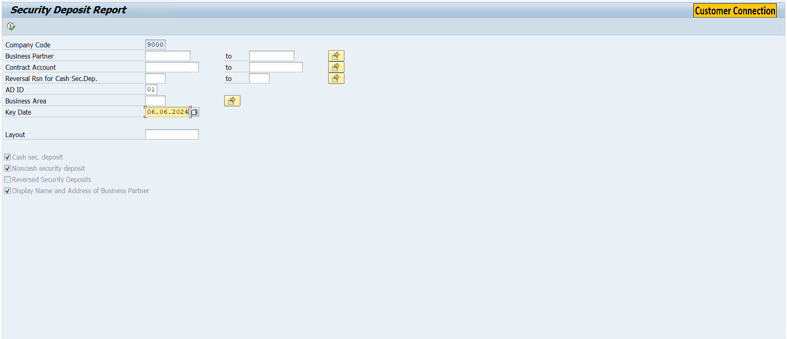
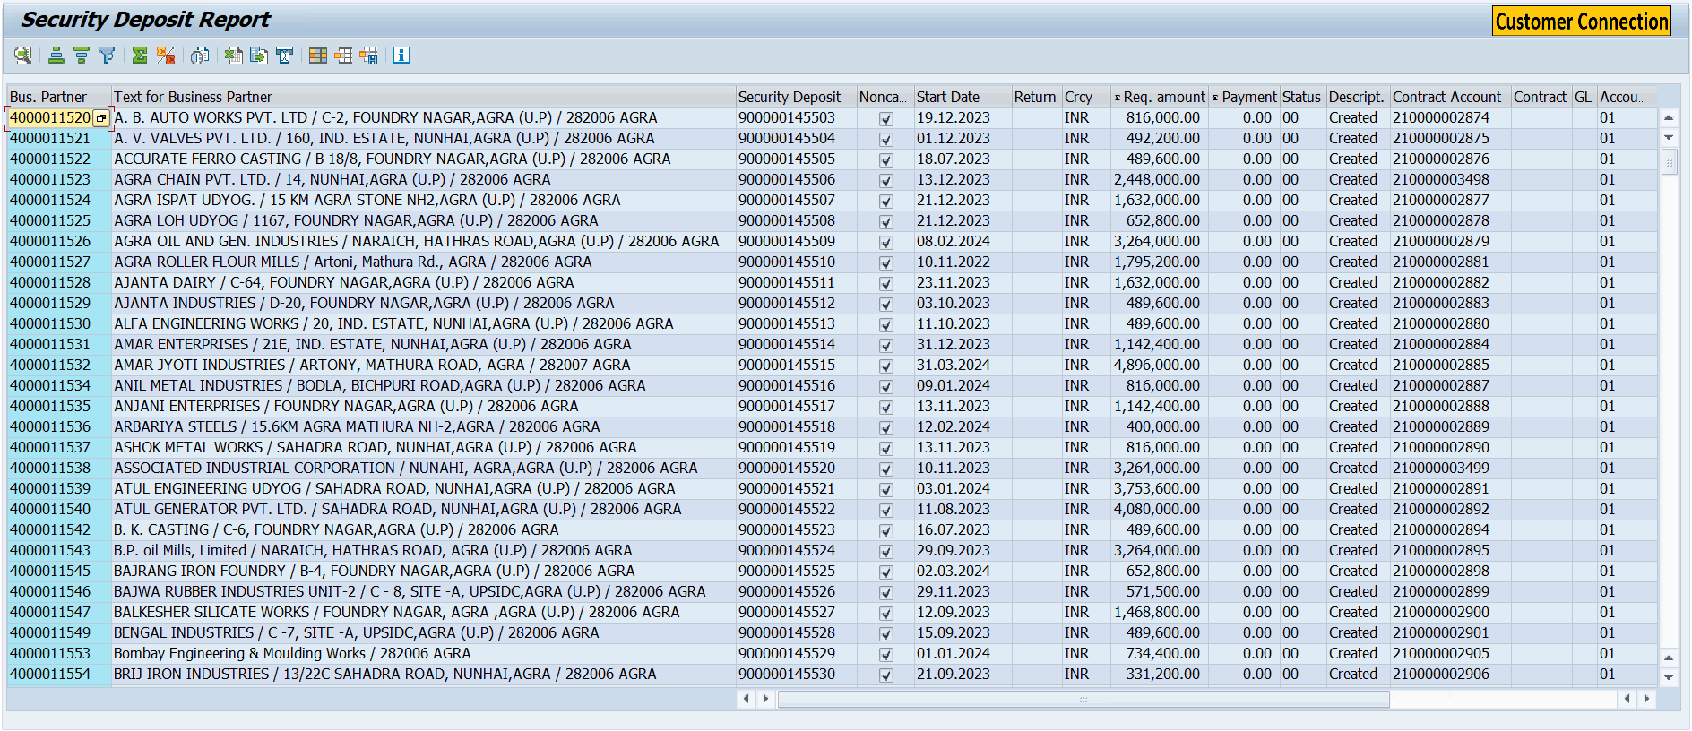

- Fiori Screen:


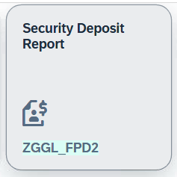

Technical Spec Original Sign Off:

Names and Signatures:

_____________ARNAV JOHRI_______________________________ Date: ___22/05/2025________

____________________________________________________ Date: _____________

____________________________________________________ Date: _____________

____________________________________________________ Date: _____________

Modifications
< Description of Modification if any>
<Support document of the modification like screen shot of email received>

